Assignment and checklist for Unit 9: Create a media product
Brief:

You are to develop a brand new graphic novel or comic for a teenage audience. This will be an original story that will introduce the character and main narrative arc.

To do this you will need to:

- Research comic book publishers, graphic novels/comic book titles, narratives and characters portrayed within them
- Plan for the production of an original graphic novel or comic, creating a detailed proposal, script and page layout, storyboard and ways you might develop your main character further
- Develop ideas for a character to be used in a story arc within your comic
- Produce an original graphic novel or comic that conforms to your planned ideas

Unit aim

Comic books and cartoon strips have been around for a very long time from the earliest cave paintings depicting graphic scenes to the digital comics we see today. Comics have developed their own style, characters and following. Comics have served many purposes; firstly to entertain but secondly, in the case of some comics, to purvey a message to those who read it.

By completing this unit, you will understand the comic and graphic novel world. You will understand the content of a graphic novel or comic and how it relates to its target audience. You’ll be able to develop one character for an original graphic novel or comic, and plan and produce panels for an original graphic novel or comic for this character.

Task 1: Researching the world of graphic novels and comics

Learning Outcome 1: Know the graphic novels and comics industry

Pass | Merit | Distinction
P1: Describe the work of a graphic novel or comic publisher
P2: Describe a chosen graphic novel or comic product
Evidence (Remember to include the title at the top of every entry)
The proposal should be presented in a written format, which could be supported by audio-visual evidence, that demonstrates the initial planning ideas for development. You must produce sample material that could be incorporated in to the content of the proposal.

(P1) You must look at different companies from various countries that produce comics. You must look at a range of characters (a minimum of two) from each company and research the work of the writers/pencilers of each.

You must explore:
- Companies (e.g. DC Comics, Manga Entertainment, Marvel Comics, 2000 AD, DC Thompson, Fleetway Press, Image Comics)
- Product types (e.g. graphic novels, digital comics, motion comics, comic strips, manga) titles (e.g. The Incredible Hulk, Hercules, Iron Man, Astonishing X-Men, Superman, Batman, Judge Dredd, Beano, Dandy)
- Writers/pencilers, letterers/inkers/colourists (e.g. Stan Lee, Jack Kirby, Bob Kane, Will Eisner, Osamu Tezuka, Kev F Sutherland, Alan Moore)
- Genre and styles (e.g. Japanese, American, British, crime, fantasy, superhero, war)

You should evidence this by a written report or a presentation with detailed speaker notes.

(P2) You must describe a chosen graphic novel using the areas outlined below:
- Genre: Action and adventure, slice of life, crime and mystery, science fiction/fantasy, superheroes
- Panelling, text, story line, structure, visual narrative, iconography, use of formal elements (e.g. line, tone, colour), speech, thought bubbles and box placements, symbols and sound effects
- Consider how meaning is created through elements of content and style (e.g. colour, language, text, images, props, costumes), created through semiotics (e.g. connotation, denotation, signification, iconography, anchorage), created through techniques (e.g. cropping, sizing, use of captions, choice of fonts, angle of the drawn action and characters)
- Target audience (e.g. age, gender, interests)
- Back story, personality, development, their appeal to target audience.

You should evidence this by a written report or a presentation with detailed speaker notes.

Task 2: Planning for an original graphic novel or comic idea

Learning Outcome 2: Be able to plan the production of an original graphic novel or comic

Pass | Merit | Distinction
P3: Develop an original story to be told within the graphic novel or comic
P4: Create a script for the planned story
(*Synoptic assessment from Unit 2 Pre-production and planning)
P5: Plan the structure and panel layout for the proposed original graphic novel or comic
(*Synoptic assessment from Unit 2 Pre-production and planning)
Evidence (Remember to include the title at the top of every entry)
(P3) You must develop a story for an original graphic novel or comic using the areas identified below.

Create a proposal for the content that includes:
- Title, synopsis of the plot, narrative structure
- Graphic novel, comic, digital comic
- Action and adventure, slice of life, crime and mystery, science fiction/fantasy, superheroes
- Main character, additional characters (e.g. name, age, background, relationship to the narrative and main character, powers if relevant)
- Target audience (e.g. age, gender, lifestyle, appeal of the graphic novel)
- Established company (e.g. 2000 AD, Marvel), self-publishing, internet
- Copyright, intellectual property rights, slander, libel, royalties, violence, offensive language/behaviour/ material, representation, health and safety
- Storyboarding for story flow

You should evidence this using documents, video, images embedded on the blog etc.

(P4) You should create a script for the story for an original novel or comic. The evidence must be a formal script.
You should evidence this using a document embedded within the blog

(P5) You should plan the structure and scripted panel layouts including the script and panel layout as outlined below.

Discuss:
- Break writing plot into page breaks/panel breaks
- Develop a script for the character
- Break each page into panels, plan panels on each page to fit narrative
- Include dialogue bubbles/thought bubbles/captions; sound effects should be considered for panels
- Consider camera angles/shots (e.g. bird’s eye view, close-up)

Additionally, discuss ideas for creation of the comic world such as:
- Props that could be used within the comic (e.g. vehicles, guns etc.)
- Terrain
- Objects in the environment
- Colouring of the environment

You should evidence this using rough designs for the page layouts and a script proposal.

Task 3: Developing the plans for your graphic novel or comic

Learning Outcome 2: Be able to plan the production of an original graphic novel or comic

Pass | Merit | Distinction
 | M1: Produce a storyboard to illustrate the flow of the story  (*Synoptic assessment from Unit 2 Pre-production and planning) | D1: Evaluate the feasibility for further development of the main character in future stories across different media formats
Evidence (Remember to include the title at the top of every entry)
(M1) This must be done BEFORE you make your comic.
You must produce a storyboard that shows the story flow – this will not be laid out in a panel design but must show the way the story will flow.

On the storyboard it will be clear that these ideas have been generated by you. You should evidence this by:
- moodboards, summary of ideas, spider diagrams, initial character sketches
- backstory, unique character traits and/or abilities, relationship with other characters
- initial character drawings/illustrations to illustrate physical characteristics and movement, body, head, clothing.

This will be evidenced by the storyboard that has been produced (see below for an example).

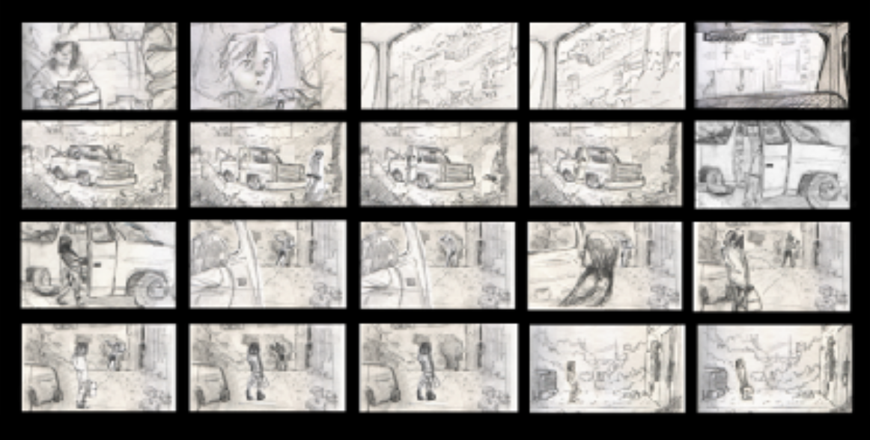

(D1) You must evaluate the feasibility of further developments of the main character across different media formats. A minimum of two must be evaluated from below:
- Video game
- Film
- Television series (live action or animated)

To give you some idea, this means how feasible is it that your character’s story will continue past this story you have made? Could this character turn up in other cross-promotions? You should evidence this by writing an essay or producing a presentation with detailed notes.

Task 4: Developing your original character

Learning Outcome 3: Be able to develop ideas for an original character for a planned story

Pass | Merit | Distinction
P6: Develop an original character to be included in the planned story | M2: Explain the characteristics and features of the original character
Evidence (Remember to include the title at the top of every entry)
(P6) You must develop an original character for inclusion into your graphic novel.

Discuss:
- Colours you may use
- Features of the character
- Clothing
- Abilities, etc.

At this stage, you must generate a range of ideas that you will develop into your final character.
You should evidence this using a spider diagram, moodboard, initial character rough sketches and a written synopsis of ideas.

(M2) You must explain your character’s defined characteristics and features.
You need to create illustrations that show the character from different angles and give ideas and details regarding facial expressions. How can you link them to the character’s personality and experiences?

This should be evidenced using designs and illustrations as well as supporting written commentary.

Task 5: Producing your graphic novel or comic

Learning Outcome 4: Be able to produce an original graphic novel or comic

Pass | Merit | Distinction
P7: Integrate the scripted character with the story line to create the final product  (*Synoptic assessment from Unit 3 Create a media product) | M3: Manipulate the visual appeal of the comic to clarify meaning | D2: Justify how the visual style of the final product follow the conventions of graphic novels or comics within its genre
Evidence (Remember to include the title at the top of every entry)
(P7) You must produce the final scripted panels. This must include your own character, environments and any props that where proposed at the planning stage based on your own proposal. Make sure your narrative is expressed in combined illustrated panels, dialogue/text, characters and your final panels can be digitally produced or hand drawn and inked.

This should be evidenced by the final comic or graphic novel.

(M3) You must manipulate the visual appeal of the comic to clarify meaning.

Discuss the following points and present annotations:
- Manipulate the visual appeal of the comic to clarify meaning by reviewing and testing: Include self-evaluation
- Include target audience evaluation (e.g. focus group, questionnaire, face-to-face interviews)
- Consider readability (e.g. Flesch Reading Ease/Flesch-Kincaid Grade Level, grammar and spelling).

This should be evidenced by showing the before and after annotated comic panels to illustrate the manipulations

(D2) You must justify how the visual style of the final product follows the conventions of graphic novels or comics within its genre. Focus on:
- Consideration of images used,
- colouring of characters and environment,
- font size and style,
- story flow,
- panel layout,
- use of speech, thought bubble and box placement, lettering,
- perspective,
- symbols
- sound effects

This should be evidenced by a formal written report with panels used to evidence the conventions followed and the genre that has been met.

