Create a Weebly account: www.weebly.com 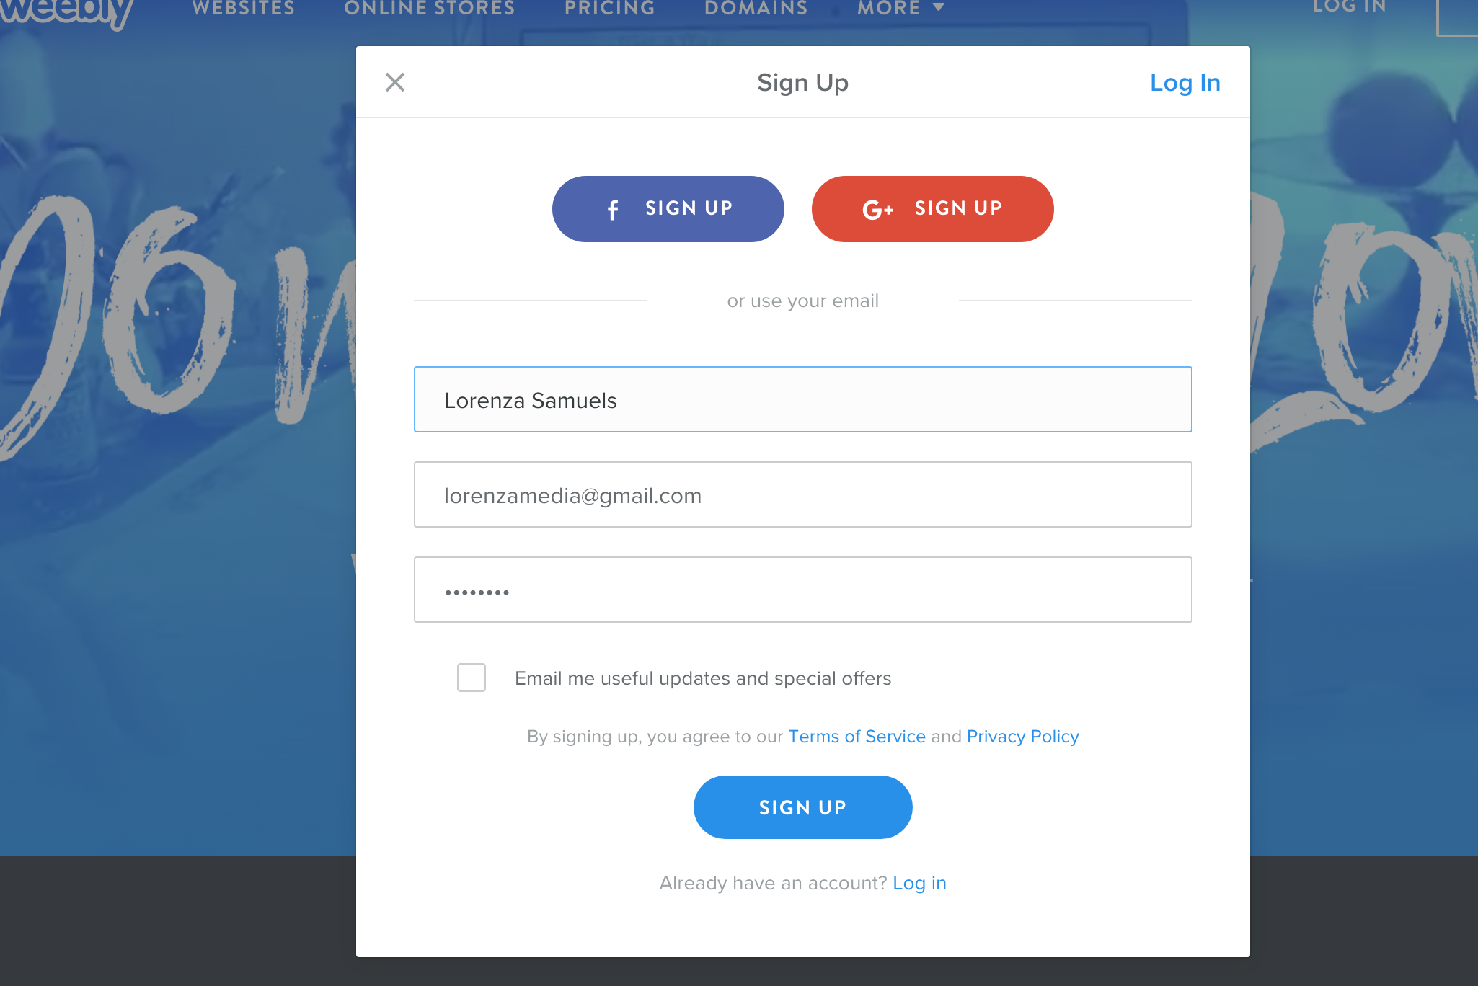

- Click sign up and use your school email and create a password (Please write this in your planner so you don’t forget).
- Click “not now” as you’re not using the page to sell
- Select a theme that you like
- Then click start editing.
- Create your subdomain as your fullname11.weebly.com
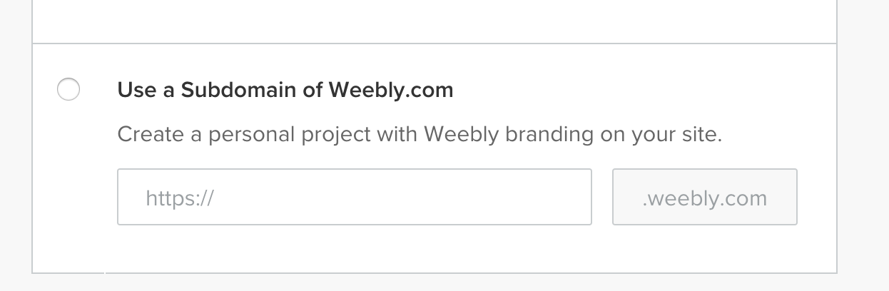
- Create pages for Action Adventure and TV Comedy.

