Create a listening schedule using internet and DAB stations for the following listeners:

Tim:”I love classical music, especially Mahler and Mozart!”

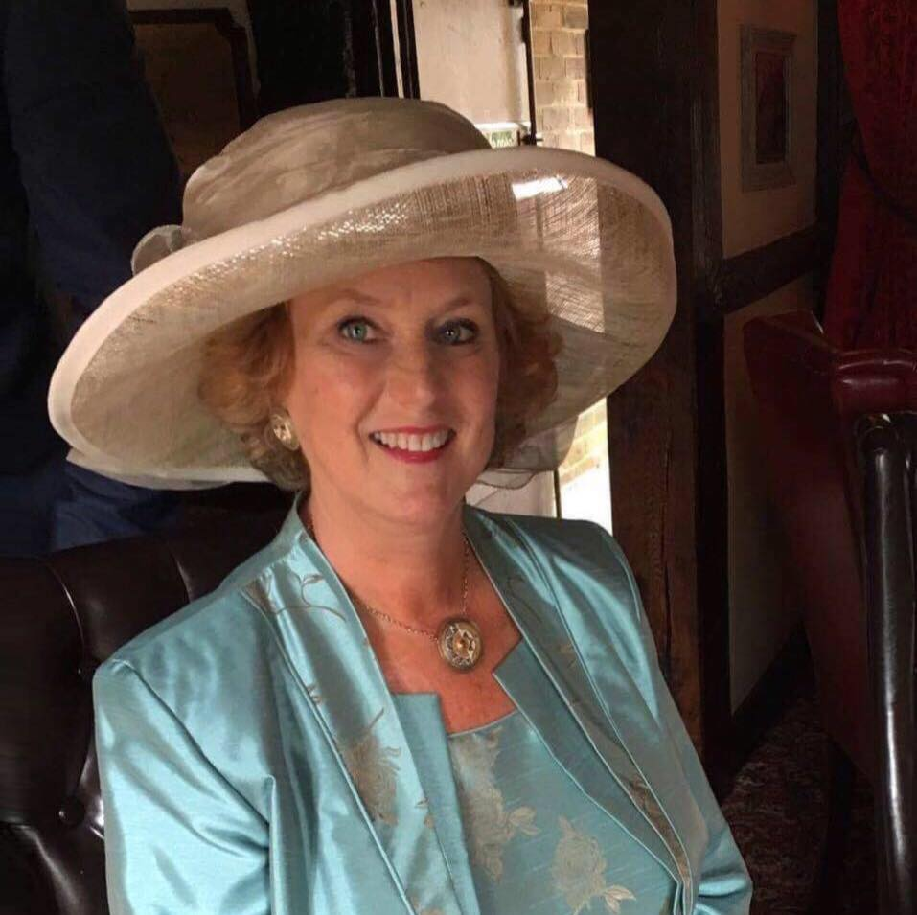
Mary “Whilst ironing, radio dramas are amazing – they take me to places I’ve never been before!”

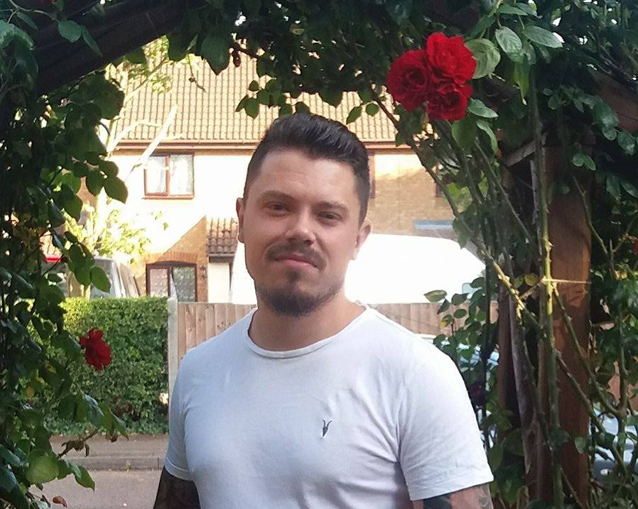
Dean “After being in USA for the summer, I’m in love with country music! Would love to listen to it some more!”

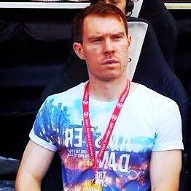
Tom “Never miss an Arsenal match, infact anything footy related is my cup of tea!”

Theresa “Growing up in the 80s – the music gives me such great memories – I’d listen 24/7 if I could!”.

Alex “I used to love old school garage, but I’m really feeling the new flavour of Afro beats, Dubstep and Grime which seems to be in the UK right now!”

